CET 310

Software Enterprise

Self-reflection on experience of business activity

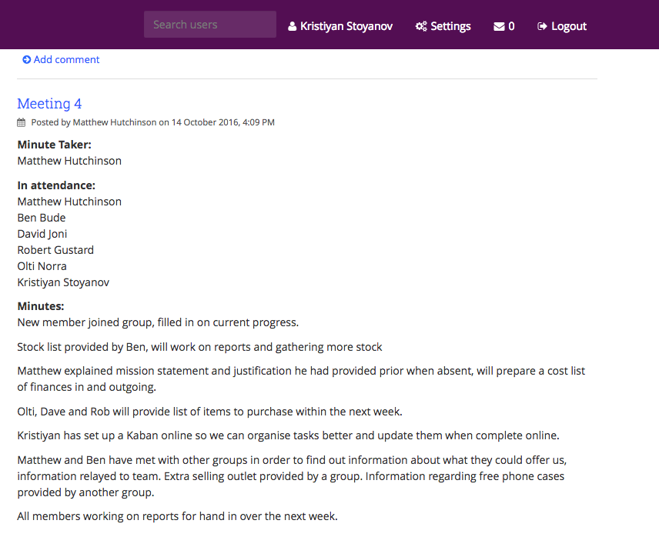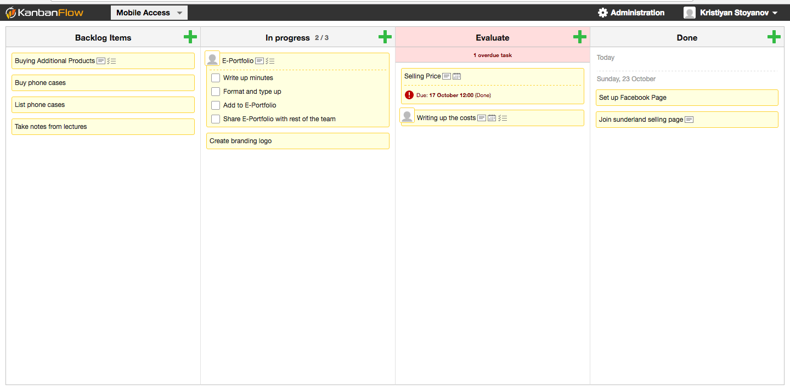I joined team number 6th on 10/10/2016 **Picture 1** including five group members more. I have not been assigned a particular role in the team. During my first session with the team I have suggested to set up an electronic Kanban board **Picture 1.1**, which was going to help us track work items, provide and include as evidence in reports. I have explained to the group how beneficial can be to use such methodologies and tools, for purpose of establishing collaboration on the project. Each team-member has been invited by email. Only the team leader is currently working on it with me.

Picture 1.1

Picture 1

I have helped the group to establish a company name. During the sprint I was responsible to do research **Picture 3** on popular makers of IPhone cases. A research has been done on [www.apple.co.uk](http://www.apple.co.uk) to have a look at prices, brands, colors, materials on various of phone cases. I asked the group if there is possibility that can establish target dates for each tasks meant to be accomplished. Unfortunately nobody responded on my request. My personal opinion felt that just only two member of the group are keen to accomplish the work, rest of the team is unaware what is going on. As an example our logo had to be done by Monday 24th of October, and in fact has not been done. I have asked if I can undertake on that task in order to complete it and be ready to sell. The team member responsible for accomplishing responded that a partial logo has been created, which I have not seen yet. Personally I think that people do not have the right attitude as team workers. The problem I find is people are not assigned to a role, so work is shuffles around. The team leader could have been assigned roles to each person in the team. That would of helped us to distribute the work around.

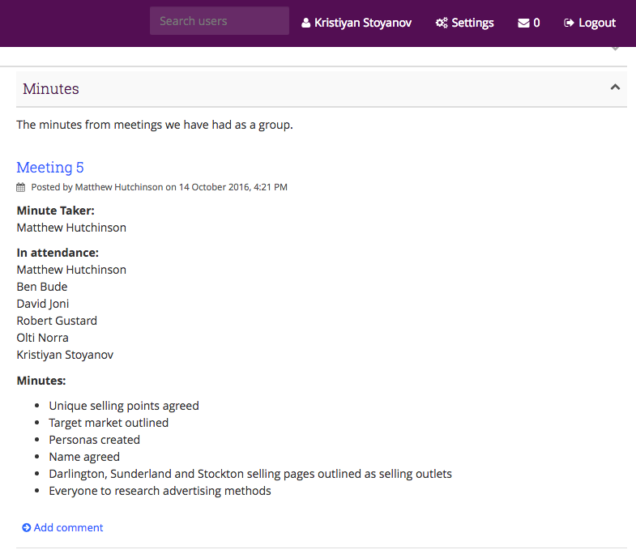

Picture 3

During the sprint I also spent some time thinking about how can current team structure can be improved. I have learned about organizational structure during lectures, different types of roles such as outgoing, ingoing roles in a company. I have already have heard of these, as I did my year in industry.